**ICTD 2024 Conference Program: 9-11, December 2024**

|  |  |  |  |  |
| --- | --- | --- | --- | --- |
| **DAY 1:**  **9/12/2024** | **TIME** | **Activity/Topic** | **Room** | **Leader/Speaker** |
|  | 8:00-8:30 | Registration |  | Joan Githua |
|  | 8.30-8.45 | Introduction/ICTD 2024 objectives | Main Hall | Prof Muliaro Wafula, General Chair ICTD2024 Org Committee |
|  | 8.45-9.00 | Welcome Remarks | Main Hall | Prof Dominic Byarubaga AICAD CEO |
|  | 9.00-9.30 | Open Science Landscape in Africa | Main Hall | Prof Muliaro Wafula |
|  | 9.30-10.00 | Official Opening Speech | Main Hall | Hon Dr Margaret Nyambura Cabinet Secretary, Ministry of ICT and Digital Economy |
|  | **10.00-10.30** | **Photo Session/Tea Break** |  |  |
|  |  | **Session 1: Data Governance and Ethics** | **Room** | **Leader/Speaker** |
|  | 10.30-10.45 | Data Protection in the Digital Age: A Comparative Analysis of Nigeria’s NDPA and the EU’s GDPR | Main Hall | Abasifiok Okonko |
|  | 10.45-11.00 | An In-depth Analysis of Caste-based Inequity in Welfare Allocation of the National Rural Employment Guarantee Scheme in India | Main Hall | Ashima Mittal |
|  | 11.00-11.15 | AI4Bangladesh: AI Ethics for Bangladesh - Challenges, Risks, Principles, and Suggestions | Main Hall | Nova Ahmed |
|  | 11.15-11.45 | Q& A | Main Hall |  |
|  |  | **Session 2: Health and Well-being** | **Room** | **Leader/Speaker** |
|  | 11.45-12.00 | The Ancient Elephant in the Room: Stigma, Gender Norms, and Cultural Barriers in Reproductive Care in Bangladesh | Main Hall | Hafsah Mahzabin Chowdhury |
|  | 12.00-12.15 | Smart Sheba: Enhancing Elderly User Experience with LLM-Enabled Chatbots and User-Centered Design | Main Hall | Sharfuddin Khan Chisty |
|  | 12.15-12.30 | Beyond Digital Interventions: Human-Centered Design for Adolescents’ Type 1 Diabetes Management in LMICs | Main Hall | Susan Wyche |
|  | 12.30-13.00 | Q & A | Main Hall |  |
|  | 13.00-14.00 | **Lunch Break** |  |  |
|  |  | Open Session 1 | Room | **Leader/Speaker** |
|  | 14.00-15.30 | Open Science Implementation Framework for Africa | Main Hall | Joseph Wafula & Agnes Kiragga |
|  |  | Co-Design and Gender in ICT4D/ICTD Research: Panel | Room 1 | Melissa Densmore |
|  |  | AI and Society: Questions and Possibilities for the "Others" | Room 2 | Faheem Hussain |
|  |  |  |  |  |
|  | 15.30-17.00 | Re-imagining Information Communication Technology and Development (ICTD) | Main Hall | Susan Wyche |
|  |  | Co-Design and Gender in ICT4D/ICTD Research: Toolkits | Room 1 | Melissa Densmore |
|  |  | Social Media and Cultural Dominance: Perspectives and Challenges in the Digital Age | Room 2 | Benjamin Akinmoyeye |
|  | 17.00-18.00 | **Poster Viewing and Networking/Tea Break** |  |  |
|  |  |  |  |  |
|  | END OF DAY 1 |  |  |  |
|  |  |  |  |  |
| **DAY 2: 10/12/2024** | **TIME** | **Activity/Topic** | **Room** | **Leader/Speaker** |
|  | 8:00-8:30 | Registration |  |  |
|  | 8.30-9.00 | Keynote Speaker | Main Hall |  |
|  | 9.00-9.15 | Barriers to transformation in the South African banking sector | Main Hall | Temitope Oluwaseyi |
|  | 9.00-9.15 | A Decade Later - Revisiting the Untapped Potential of Mobile Learning with Smartphones in Ghana’s Higher Secondary Education | Room 1 | Alois Paul Spiesberger |
|  | 9:15-9:20 | Q & A |  |  |
|  | 9.20-9.35 | Cultural Dominance on Social Media: Experiences of Namibian and Nigerian Young Adults | Main Hall | Kentaro Toyama |
|  | 9.20-9.35 | ChatGPT In The Classroom: Guidelines for Integrating AI-Assisted Learning into Pakistani Children’s Academic Journey | Room 1 | Suleman Shahid |
|  | 9:35-9:40 | Q&A |  |  |
|  | 9.40-9.55 | From Hobby to Career: Exploring Professional eSports in Bangladesh | Main Hall |  |
|  | 9.40-9.55 | Initial Observations from Field Testing of a Digital Participatory Tool to Improve Water Security in Rural India | Room 1 | Shivani Ashok Kumar Mehta |
|  | 9.55-10.00 | Q&A |  |  |
|  | **10.30-11.00** | **Tea Break** |  |  |
|  |  | **Session 3: Sustainability and Resource Monitoring** | **Room** | **Leader/Speaker** |
|  | 11.00-11.15 | Crowdsourcing Safety: The Value of Passenger Feedback for Measuring Driving Safety | Main Hall |  |
|  | 11.15-11.30 | Scalable Monitoring of Tree Canopy Density and Height in India at High Spatial Resolutions | Main Hall | Dhruvi Goyal |
|  | 11.30-11.45 | Q&A | Main Hall |  |
|  | 11.45-12.00 | TVWS Network Resilience in Rural Towns: How External Factors Impact Network Performance and Social Factors Impact Network Longevity | Main Hall | Vaasu Taneja |
|  | 12.00-12.15 | The GAIUS Experience: Powering a Hyperlocal Mobile Web for Communities in Emerging Regions | Main Hall | Rohail Asim |
|  | 12.15-12.30 | Q&A | Main Hall |  |
|  | **13.00-14.00** | **Lunch Break** |  |  |
|  |  | **Session 4: Community Empowerment** | **Room** | **Leader/Speaker** |
|  | 14.00-14.15 | From Exclusion to Inclusion: Digital Platforms as a Pathway for Hijra (Third Gender) Employment | Main Hall | Md. Alvi Islam Ratul |
|  | 14.15-14.30 | Leaving No One Behind: An Agenda for Voice-based Engagement of Remote Communities | Main Hall | Md Adnan Islam |
|  | 14.30-14.45 | "I wish I had the ability to vote to select my own leaders… Rohingya Refugees Quest for Democracy in the Digital Age | Main Hall | Faheem Hussain |
|  | 14.45-15.15 | Q&A | Main Hall |  |
|  |  | **Session 5: Media and Participation** | **Room** | **Leader/Speaker** |
|  | 15.15-15.30 | A Civics-oriented Approach to Understanding Intersectionally Marginalized Users' Experience with Hate Speech Online | Main Hall | Achhiya Sultana |
|  | 15.30-16.15 | Filter-in or Filter-out: Complexities and Implications of Content Moderation Processes in a Voice-based Participatory Media Platform in India | Main Hall | Saurabh Jain |
|  | 16.15-16.30 | Investigating the Crowdfunding Communication Gap Between the Campaign Creators and Backers: a Case from Namibia | Main Hall | Anna Karolina Mueller |
|  | 16.30-17.00 | Q&A | Main Hall |  |
|  |  | **Open Session 2** | **Room** | **Leader/Speaker** |
|  | 14.00-15.30 | Dismantling digital colonisation. Academics, practitioners and policy makers confronting what keeps us up at night. | Room 1 | Nyamwaya Munthali |
|  | 15.30-17.00 | Gender Justice in STEM | Room 1 | Chisenga Muyoya |
|  | **17.00-18.00** | **Poster Viewing and Networking/Tea Break** |  |  |
|  |  |  |  |  |
|  |  |  |  |  |
|  | END OF DAY 2 |  |  |  |
|  |  |  |  |  |
|  |  |  |  |  |
| **DAY 3: 11/12/2024** | **TIME** | **Activity/Topic** | **Room** | **Leader/Speaker** |
|  | 8:00-8:30 | Registration |  |  |
|  |  | **Session 6: AI/ML in Development Contexts** | **Room** | **Leader/Speaker** |
|  | 8.30-8.45 | Tinea Skin Disease Network (TiSkiD-Net): Detecting Tinea Skin Diseases through Lightweight and Unbiased Deep CNN | Main Hall | Rantu Das |
|  | 8.45-9.00 | AI in Education Unplugged Support Equity Between Rural and Urban Areas in Brazil | Main Hall | Carlos Portela |
|  | 9.00 -9.15 | Near Feasibility, Distant Practicality: Empirical Analysis of Deploying and Using LLMs on Resource-Constrained Smartphones | Main Hall | Mateus Monteiro Santos |
|  | 9.15-9.45 | Q&A |  |  |
|  | **10.00-10.30** | **Tea Break** |  |  |
|  |  | **Open Session 3** | **Room** | **Leader/Speaker** |
|  | 10.30-12.00 | A Framework for mainstreaming Artificial Intelligence as an Accelerator for Achieving SDG 4: Quality Education for All | Main Hall | Agnes Mindila |
|  | 10.30-12.00 | HCI across borders and aspirations | Room 1 | Vikram Kamath Cannanure |
|  | 10.30-12.00 | Technology in the Humanitarian Space: An Approach for Fostering Improved Accountability for Digital Products | Room 2 | Omar Abou-Samra |
|  | 12.00-13.30 | AI Ethics in Global South: Conversation of Continents | Main Hall | Tahsin Mayeeshal |
|  | 12.00-13.30 | HCI across borders and aspirations | Room 1 | Vikram Kamath Cannanure |
|  | **13.30-14.30** | **Lunch Break** |  |  |
|  | 14.30-16.00 | Closing Session |  |  |
|  | **16.00-16.30** | **Tea break** |  |  |
|  | 16.30-17.30 |  |  |  |
|  | **END OF DAY 3** | **END OF CONFERENCE** |  |  |
|  |  |  |  |  |
|  |  |  |  |  |

**SPEAKERS**

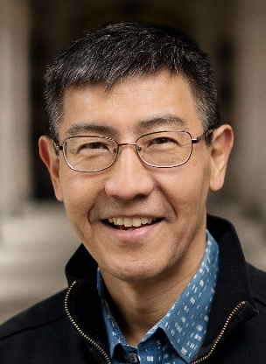**Kentaro Toyama**

**Paper: Cultural Dominance on Social Media: Experiences of Namibian and Nigerian Young Adults**

Kentaro Toyama is W.K. Kellogg Professor of Community Information at the University of Michigan School of Information and a fellow of the Dalai Lama Center for Ethics and Transformative Values at MIT. He is the author of Geek Heresy: Rescuing Social Change from the Cult of Technology. Until 2009, Toyama was assistant managing director of Microsoft Research India, which he co-founded in 2005. At MSR India, he started the Technology for Emerging Markets research group, which conducts interdisciplinary research to understand how the world's poorest communities interact with electronic technology and to invent new ways for technology to support their socio-economic development. His work has been mentioned by the New York Times, BBC, Wall Street Journal, Washington Post, and NPR. Prior to his time in India, Toyama did research in artificial intelligence and human-computer interaction, and taught mathematics at Ashesi University in Ghana. He is a co-founder of the International Conference on Information & Communication Technologies and Development and served as the co-editor-in-chief of the journal Information Technologies & International Development

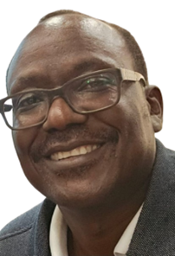**Wafula Muliaro**

**Paper: Open Science Landscape in Africa**

Prof. Joseph Muliaro Wafula is an Associate Professor of Computing at JKUAT and founding Director of the ICT Centre of Excellence and Open Data (iCEOD). He holds a PhD in Information Technology (JKUAT), MSc in Physics (University of Nairobi), M.Phil. in Microelectronic Engineering and Semiconductor Physics (Cambridge) Certified by IBM in Mobile Application Development, Cyber Security, and Data Engineering, he leads pioneering initiatives in open science and data-sharing platforms. Currently, Prof. Wafula heads projects like the Data Sharing Platform for Researchers in Africa (DASSA) funded by APHRC and the Africa Open Science Platform (AOSP) Eastern Africa Node Initiative, in partnership with AICAD. He has also developed Kenya’s Ministry of Health Data Repository and contributed to the African Policy Framework for Open Science. His work includes blockchain applications for vaccine supply chains and capacity-building programs across Africa. He was awarded the Kenya Open Data Champion Award (2016) and IBM Shared University Research Award (2016). He is a fellow of the Computer Society of Kenya and Cambridge Commonwealth Society. He has served as an Executive Member of CODATA International, published widely, and continues to shape policy and research in digital development and open data.



**Dorothea Kleine**

Prof. Dorothea Kleine is the Director of the Institute for Global Sustainable Development at the University of Sheffield, leading the Digital Technologies, Data, and Innovation group. Her work focuses on sustainable development, global justice, and the role of digital technologies in advancing these aims. She is renowned for the Choice Framework, which applies the capabilities approach to ICTD/ICT4D, as outlined in her book Technologies of Choice? (MIT Press). Prof. Kleine’s research spans Africa, Latin America, Europe, and the Middle East, using participatory methods such as action research and co-design. Her projects, funded by UKRI, ESRC, DFID/FCDO, IDRC, and others, include the GCRF UKRI Gender-Justice in Digital Innovation in Africa and the IDRC-funded Gender-Justice in STEM Research in Africa. She has collaborated with organizations like UNCTAD, ILO, UNICEF, UNEP, and GIZ. Her latest book, Digital Reset: Redirecting Technologies for the Deep Sustainability Transformation (2023), is freely available online. Previously, she directed the ICT4D Centre at Royal Holloway, University of London, and has held roles at the University of Cambridge, Bonn University, and Harvard University. Educated at LMU Munich, TUM, and Oxford, she earned her PhD at the LSE.In the ICTD community, she co-introduced Open Sessions at ICTD2010, served on program and steering committees, and co-led the adoption of ethical standards for ICT4D research at ICTD2019.

**Abasifiok Okokon**

**Paper: Data Protection in the Digital Age: A Comparative Analysis of Nigeria’s NDPA and the EU’s GDPR**

Abasifiok Okokon is a political science student at the University of Uyo, Akwa Ibom State, Nigeria, with a keen focus on addressing governance challenges locally and globally. Her academic interests include public policy and administration, comparative politics, and international relations, particularly the societal impacts of policies and governance. Her current research examines the Nigeria Data Protection Act (NDPA), aiming to strengthen the Act by conducting a comparative analysis of global data protection frameworks. This work identifies gaps and proposes improvements to better safeguard citizens’ data while fostering digital growth. Beyond academics, Abasifiok enjoys cooking, exploring cultural diversity through cuisine, reading novels to gain broader perspectives, and watching movies to relax and gain insights into global issues. These hobbies reflect her balance of intellectual and creative pursuits.

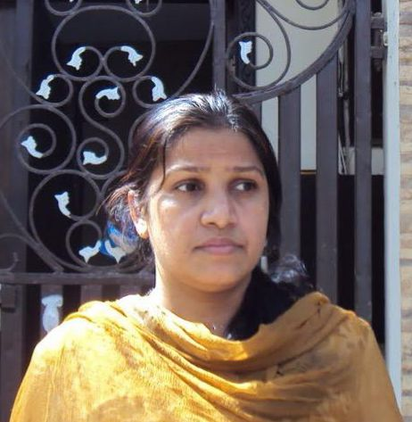**Ashima Mittal**

**Paper: Cultural Dominance on Social Media: Experiences of Namibian and Nigerian Young Adults**

Ashima Mittal is a PhD scholar at IIT Delhi with a solid foundation in Computer Science, Engineering, and Information Technology. She graduated with Honors in Computer Science & Engineering in 1995, earning a University Gold Medal for academic excellence. She later completed a Master’s in Information Technology in the United States, enhancing her global perspective in the field. With over 20 years of experience in the IT industry, including in the financial sector, Ashima is also an Oracle Certified Professional (DBA). Her career has been driven by a passion for applying technology to address real-world challenges, which led her to explore the intersection of technology and economics. Ashima’s PhD research reflects her commitment to cross-disciplinary solutions. She focuses on monitoring and improving the performance of social welfare schemes, particularly MGNREGS, through data analytics. By integrating Computer Science and Economics, her work tackles critical societal issues, demonstrating the practical impact of her expertise. Pursuing a PhD in Information and Communication Technology for Development (ICTD) enables Ashima to align her technical knowledge with her dedication to social impact. Through her research, she aims to advance her vision of leveraging technology to improve lives and contribute meaningfully to societal development.

**Susan Wyche**

**Paper: Beyond Digital Interventions: Human-Centered Design for Adolescents’ Type 1 Diabetes Management in LMICs**

Dr. Susan Wyche is an Associate Professor in the Department of Media and Information at Michigan State University (MSU) and has a courtesy appointment in MSU’s African Studies Center. Her research primarily contributes to the Human-Computer Interaction (HCI) and Information and Communication Technology for Development (ICTD) fields. She focuses on developing an understanding of technology use in Sub-Saharan Africa that is grounded in people’s experiences. To achieve this goal, she conducts fieldwork in—primarily rural Kenyan sites—that she has been visiting since 2008. Dr. Wyche has explored various technology-related topics, including mobile phones, social media, and agricultural hand tools. This research is funded by awards from Google, Facebook, Mozilla, the United States Agency for International Development (USAID), and the National Institutes of Health (NIH). She earned her PhD in Human-Centered Computing from Georgia Tech, an MS from Cornell University, and an undergraduate degree in Industrial Design from Carnegie Mellon University. Before pursuing her PhD, Susan worked as a professional designer in the housewares industry.

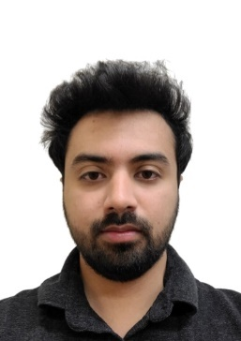**Rohail Asim**

**Paper: Cultural Dominance on Social Media: Experiences of Namibian and Nigerian Young Adults**

Rohail Asim is a PhD candidate at New York University. His research focuses on the domains of Computer Networks and Web Accessibility in developing regions. His research includes the development of new systems to reduce the bandwidth, cost, and computational requirements of the web in developing regions; the development of systems that increase internet penetration, availability, and usage in developing regions with locally relevant content; as well as the analysis and advancement of Congestion Control protocols for emerging applications.

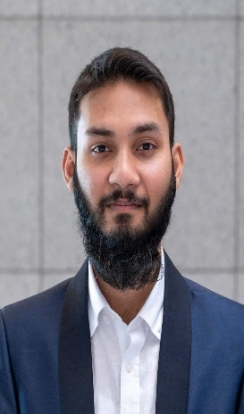

**Adnan Islam**

**Paper: Leaving No One Behind: An Agenda for Voice-based Engagement of Remote Communities**

Adnan is a PhD candidate in the Action Lab at the Faculty of Information Technology, Monash University, Australia. His research advocates for distributed community engagement, addressing the digital divide as a barrier to diverse voices and perspectives. Exploring strategies beyond internet connectivity, his work focuses on telephony-based platforms that prioritize critical design considerations and robust record-keeping practices for voice-driven community engagement. Adnan aims to foster inclusivity and accessibility in global community discourse and decision-making processes. His primary research interests include Human-Computer Interaction, Natural Language Processing, and Social Computing, areas where he has published over 25 scholarly papers. Before starting his PhD, Adnan served as an Assistant Professor in the Department of Computer Science and Engineering at the Military Institute of Science and Technology, Bangladesh. He holds a Bachelor’s and a Master’s degree in Computer Science and Engineering from Bangladesh University of Engineering and Technology. Alongside his doctoral studies, Adnan contributes as a Teaching Fellow at Monash University. His work reflects a commitment to bridging technological gaps and empowering communities through innovative and inclusive approaches to engagement.

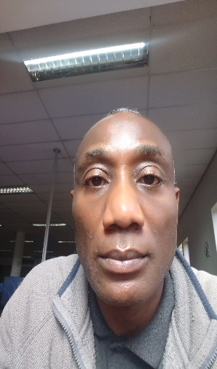**Temitope O. Tokosi**

**Paper: Barriers to transformation in the South African banking sector**

Dr. Temitope O. Tokosi is a lecturer at the Cape Peninsula University of Technology (CPUT) in Cape Town, South Africa, specializing in Management Information Systems (MIS) and Research Methodology at the postgraduate level, as well as Business Information Systems (BIS) at the undergraduate level. He holds a PhD in Information Systems from the University of the Western Cape (UWC), a Master’s in International Business from HAN University of Applied Sciences in the Netherlands, a Bachelor’s degree with Honours from UWC, and a Certificate in Service Project Management from Vrije University in the Netherlands. His research focuses on information systems and management, with interdisciplinary contributions to IT education and health informatics. A member of the South African Health Informatics Association (SAHIA) and the South African Institute of Computer Science and Information Technologists (SAICSIT), he has published research articles, contributed book chapters, and presented at both local and international conferences. His academic contributions include supervising Master’s students, with doctoral supervision currently underway. He has also served as an independent contractor for universities, an external examiner, a journal peer reviewer, and a consultant. He actively engages in funding proposal development and has successfully completed a government-funded research project in South Africa. His work reflects a dedication to advancing knowledge and fostering innovation in the fields of information systems and education.



**Anna Muller**

**Paper: Investigating the Crowdfunding Communication Gap Between the Campaign Creators and Backers: a Case from Namibia**

Anna Müller is a user-centric designer and Master of Science from Helsinki, Finland. Anna will be presenting her research on a charitable crowdfunding platform developed by a research group in Namibia University of Science and Technology, where she did her exchange studies in 2022. Crowdfunding has been thought to be a potential tool for small-scale entrepreneurs in the Global South to find funding for their businesses. However, a gap in communication remains between the potential campaign backers and the entrepreneurs creating crowdfunding campaigns. Anna worked with Namibian crowdfunding campaign creators, and their potential backers to investigate this gap. She will present her findings on the gap and offer recommendations for crowdfunding platforms to design user interfaces and experiences that effectively support campaign creators.

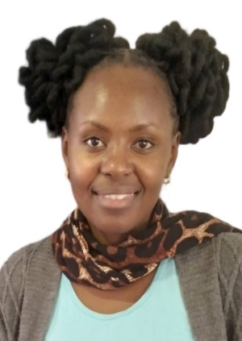 **Lillian Mathu**

**Paper: Beyond Digital Interventions: Human-Centered Design for Adolescents’ Type 1 Diabetes Management in LMICs**

Lilian Mathu is a trained software engineer with a strong focus on human-centered design. She holds a degree in Information Technology from Maseno University, along with certifications in Cyber Security from Strathmore University, Software Development from Lakehub Academy, and Health Information Systems from Health Informatics for Kenya (HI4Kenya). For the past five years, Lilian has applied human-centered design principles to develop innovative solutions in the healthcare industry. Her contributions include designing a paper-based diary to support teens in managing Type 1 Diabetes, creating a 2G-based solution (SMS and USSD) to improve Reproductive, Maternal, Newborn, Child, and Adolescent Health (RMNCAH) outcomes in underserved counties in Kenya, and developing a web-based cancer screening tool to enhance early detection and improve the prognosis of breast and cervical cancer. Through her work, Lilian demonstrates a commitment to leveraging technology and design to address critical healthcare challenges and improve community well-being.



**Mizanur Rahman**

**Paper: The Ancient Elephant in the Room: Stigma, Gender Norms, and Cultural Barriers in Reproductive Care in Bangladesh**

A.T.M. Mizanur Rahman is a first-year PhD student in Computer Science at the University of Illinois Urbana-Champaign. His research focuses on Human-Computer Interaction (HCI) and Information and Communication Technologies for Development (ICTD). Currently, he is investigating the role of ghost workers from the Global South in shaping and sustaining artificial intelligence systems. He completed his bachelor's degree at the Bangladesh University of Engineering and Technology (BUET), where he developed a strong interest in doing research for the betterment of marginalized communities.

** Shivani Ashok Mehta**

**Paper: Initial Observations from Field Testing of a Digital Participatory Tool to Improve Water Security in Rural India**

Shivani is a PhD student under Professor Aaditeshwar Seth at the Indian Institute of Technology Delhi, India. Her research focuses on unraveling the intricate relationships between water, climate, and land to support sustainable agriculture for rural communities in India.In her work, Shivani transforms complex data into actionable insights, empowering rural communities to address environmental challenges. She thrives in both academic and outdoor environments, seamlessly balancing rigorous lab analysis with immersive fieldwork. This approach turns her research into a dynamic journey of discovery, fostering innovation and practical solutions.Beyond her academic pursuits, Shivani channels her adventurous spirit into trekking, finding inspiration and rejuvenation in nature’s expansive landscapes.

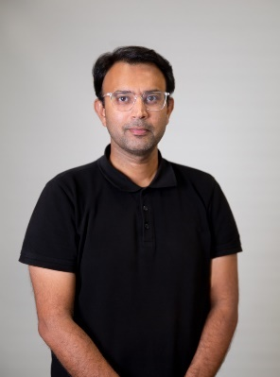

**Suleman Shahid**

**Paper: ChatGPT In The Classroom: Guidelines for Integrating AI-Assisted Learning into Pakistani Children’s Academic Journey**

Suleman Shahid is an Associate Professor of Computer Science at the Lahore University of Management Sciences (LUMS) and the founding director of the LUMSx - Online Learning Center at LUMS. At LUMS, he directs the 'Computer-Human Interaction for Inclusion, Wellbeing and Learning' (CHISEL) Lab, and manages the university’s Usability Lab. Suleman’s primary area of interest is designing learning and healthcare technologies for/with the margins in the global south with an emphasis on using participatory and inclusive design to drive innovation. His research focuses on the intersection of design, technology, and inclusion with applications to (1) assistive technologies (mobile apps and VR/AR systems) to enhance the quality of life of persons with disabilities (e.g. autism, dyslexia, visual impairment, dementia), and persons with mental health conditions (e.g. anxiety, depression), and (2) learning and playful technologies for children. He works with private and public sectors on design-driven innovation, people-centred change management, and digital transformation projects.

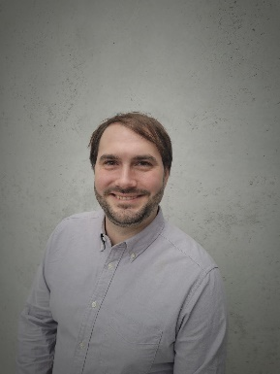 **Paul Spiesberger**

**Paper: A Decade Later - Revisiting the Untapped Potential of Mobile Learning with Smartphones in Ghana’s Higher Secondary Education**

Paul Spiesberger graduated from the Vienna University of Technology with a degree in computer science. He is currently working with INSO as the Operative Head of ROTA and lecturer in the field of mobile technologies and ICT4D. Since 2024, he has been working at the Institute of Software Technology located at TU Graz. Paul is also employed as a senior lead software engineer for mobile technologies at RISE. In the past, he won several national and international awards for his work at Os – a collective to tackle social issues with ICTs. Since 2014 Paul has been the chair of ICT4D.at, and in 2021, he joined the ICT4D Collective

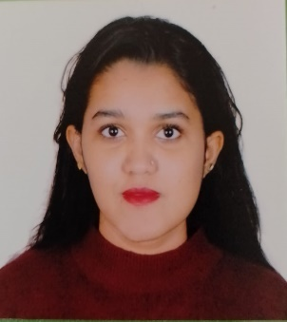

**Hafsah Mahzabin Chowdhury**

**Paper: The Ancient Elephant in the Room: Stigma, Gender Norms, and Cultural Barriers in Reproductive Care in Bangladesh**

Hafsah Mahzabin Chowdhury is a first-year PhD student in Computer Science at the University of Illinois Urbana-Champaign. Her research centers on Human-Computer Interaction (HCI) and Information and Communication Technologies for Development (ICTD). Her recent work examines reproductive healthcare access in rural Bangladesh, exploring the influence of sociocultural norms and gender dynamics on healthcare decision-making. Hafsah holds a bachelor’s degree in Computer Science from the Military Institute of Science and Technology (MIST). She looks forward to presenting her research at ICTD 2024 and collaborating with researchers and practitioners to advance technology-driven solutions for global development.

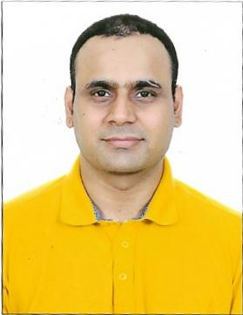**Saurabh Jain**

**Paper: Filter-in or Filter-out: Complexities and Implications of Content Moderation Processes in a Voice-based Participatory Media Platform in India**

Saurabh Jain is a PhD scholar at IIT Delhi under Professor Aaditeshwar Seth, specializing in Human-Computer Interaction (HCI) with a focus on ethical technology use. His research addresses social biases in information systems, recently collaborating with Gram Vaani Community Media on content moderation in voice-based participatory platforms. With postgraduate degrees in Computer Science, Political Science, and Psychology, Saurabh previously co-authored research on computer networks at the University of Minnesota, Twin Cities. Professionally, he has worked with organizations like Citrix, Local Circles, IBM, and served as a Lecturer at BITS Pilani, Dubai. Currently, he is Deputy Director of Income Tax (Systems) at India’s Ministry of Finance. Driven by interdisciplinary expertise, Saurabh advocates for ethical, inclusive online spaces. Outside academia, he enjoys running, meditating, blogging, and spending time with his child.

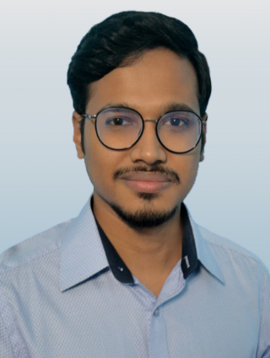

**Md. Alvi Islam Ratul**

**Paper: From Exclusion to Inclusion: Digital Platforms as a Pathway for Hijra (Third Gender) Employment**

Md. Alvi Islam Ratul is an undergraduate Computer Science student at BRAC University in Bangladesh. Growing up in the Global South, he has witnessed the unique challenges and opportunities that technology presents in resource-constrained environments. This lived experience drives his passion for Human-Computer Interaction (HCI) and Information and Communication Technologies for Development (ICT4D). Alvi focuses on designing accessible and intuitive digital experiences to bridge the digital divide and promote inclusion for marginalized populations. Beyond academics, he has facilitated Project Srijon, an initiative promoting gender equality, skill development, and social awareness among students from underprivileged communities. Combining his technical expertise and commitment to social impact, Alvi aspires to foster technological innovations that empower marginalized communities while addressing their unique needs. He envisions his contributions benefiting not only the Global South but also advancing inclusive development globally.